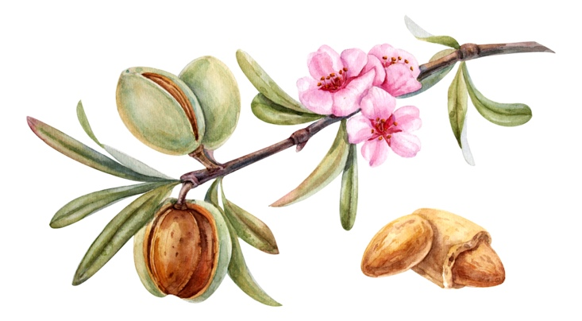

October 15, 2025

When they say: There is peace and security. Then an unexpected destruction will befall them. Like the labor pains of a pregnant woman and they will certainly not flee from it.
1 Thessalonians 5:3.
We have come at a very crucial moment in the history of mankind. The fulfillment of the prophecies of the last days. There is peace now, but that will change suddenly. This prophecy of Paul points to the imminent return of Christ. He calls us to be vigilant. Be vigilant about your life, walk and relationship with God through Jesus. A day that will come for many like a thief in the night because they have not (fully) prepared themselves for an encounter with Him.

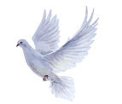
Make your house and life in order for the Lord Jesus.
And become like children of the day, clothed with the breastplate of faith and love, and with the hope of salvation as a helmet. 1 Thessalonians 5:8. Ephesians 6:17.
About the period in which we now live, the coming of the Lord Jesus, the outpouring of His Spirit over all the earth and on all flesh, the fall of Babylon, the labor pains that are now going over the earth, are events or events that ultimately lead to the return of the Lord Jesus on the clouds as prophesied in Zechariah.
Many are not prepared for what is to come and are not ready to meet the Lord Jesus and stand sanctified before him, not ready for the wedding. Their lamps are not filled with oil, the Holy Ghost. Matthew 25 but instead tried to buy oil elsewhere. Therefore, turn to the Lord Jesus. Let the word of Christ dwell in you in a rich measure, in all wisdom Colossians 3:16. Matthew 25 also says that the five wise girls had brought extra oil. Extra knowledge of the word and more of the Holy Spirit and are known by the Bridegroom.

The Way of Sanctification to Which We Are Called
1 Thessalonians 4:8.
For God has not called us to uncleanness, but to life in sanctification. Therefore, whoever rejects this, does not reject a man, but God, who has also given His Holy Spirit in us.

It is the will of God that we repent and live pure in order to be saved. Put away all sin and repent of it, ask forgiveness and walk in the light. There is no compromise possible with God, it is not possible to be saved a little or to choose Him a little. Choosing means today and completely. It is clearly described in Matthew 19:16:22. The rich young man. Choosing completely brings eternal life; And Jesus said to them; Verily I say to you who have followed me in being born again, when the Son of Man shall sit on the throne of His glory. Followed in rebirth means tried and corrected, the old man discarded from the old path of life

The second Exodus.
God makes a way, a path, and will stretch out his hand once more for all who choose him. It will be comparable to the Exodus from Egypt and the plagues. The plagues are coming back. The difficulties return. But as Christ led his people in those days, so it will be again today. 1 Corinthians 10: 4-6. (Read the article on the Second Exodus.)

Time of the labor pains and the outpouring of the Spirit.
God's love and grace in the end times.
In this time of sorrows, there will also come a time when the Lord Himself will deliver His people from this world. He himself will bring this about. All the more reason to prepare your life for Him and to keep the focus on Him and the Heavenly Jerusalem. His people are the people He has called and will call.
To this end, the outpouring of the Spirit on all flesh is also meant to give us the opportunity to give his or her life to the Lord Jesus, to ask forgiveness for sins and to follow him in truth and peace. A great act of love and Grace in the end times. Realize that all who have given His life to the Lord Jesus have become children of light, transferred into His wonderful light and a holy people. Not everyone will choose eternity, the Bible teaches us that, those who do belong to a holy people. And have been accepted in mercy. Revelation 7; After this I looked, and behold, a great multitude, which no man could number, from all nations, tribes, peoples, and tongues, stood before the throne and before the Lamb, clothed with white robes and palm branches in their hands.
But you are a chosen generation, a royal priesthood, a holy people, whom God made his own, that you might proclaim the virtues of him who called you out of darkness into his wonderful light. You who were not a people before; you who were without mercy, but now you have received mercy. 1 Peter 2:9-10. God's people are and were scattered all over the earth. He calls everyone back home. And we are also called to proclaim the word.
You are all children of light and children of day. We are not of the night nor of darkness. 1 Thessalonians 5:5.
If trouble comes, do not be afraid, even if you have to suffer for justice, for then you will be saved. Do not be afraid as they are afraid, do not be confused, and sanctify God in your hearts. 1 Peter 3.

No more servants of sin, but living according to the will of God.
1 Peter 4:5.
At a certain moment we stand before the Lord Jesus to answer for what we have done, said and thought. Therefore, live holy. A holy life in Godliness. 2 Peter 3:11. This judgment seat is meant only for believers in Christ 2 Corinthians 5:10, Romans 14:10, 1 Corinthians 3:13b-16. Concretely: As long as you still can, ask forgiveness for everything you have said about, for example, others. Or if you have been busy with things that are not in the will of God. Gossip or lies, for example. Or what you have expressed on social media channels Our thoughts are also assessed. Go in prayer and ask forgiveness for all this if necessary. Do not wait until you stand before the Lord Jesus. Ask the Holy Ghost for clarity.

For the end of all things is near. 1 Peter 4:7. Seek the prize that has been set before us, namely, everlasting life. Fight the good fight of faith and see if you are still in the faith. Fight the good fight of faith. Lay hold of eternal life, to which you are also called and have made a good confession before many witnesses. It is a commandment as we can read to observe immaculate and blameless, until the appearance of our Lord Jesus Christ. 1 Timothy 6:11-16
Are you living according to the will of God? For this is the true battle of faith, God's will and the will of man. Living according to the will of God and surrender gives peace.
The fear of the Lord brings wisdom.
The fear of the Lord, a healthy and holy respect for the Lord Jesus makes that we can live holy. The Holy Spirit helps with this. Job 28:28. But to man He said; Behold the fear of the Lord, that is wisdom, and turning away from evil is insight.
God has promised us a crown.
James 1:12.
Blessed is the man who endures temptation, for when he is proved to be tried, he will receive the crown of life, which the Lord has promised to him who love him.
Furthermore, I have in store for the crown of righteousness which the Lord, the righteous Judge, will give me on that day. And not only me but also all who have loved His appearance. 2 Timothy 4:7-8.

Pray for your neighbors as God has commanded us and those who have slipped from the word, the narrow path. Find rest in the storm with the Lord Jesus. because you believe in the Gospel. Hebrews 4. Your walk of life with the Lord Jesus begins with conversion.
This can be done anywhere at any time!

www.onzegezegendehoop.nl
D. Bakker

